39.11: a) 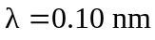
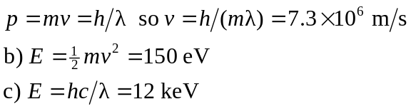
d) The electron is a better probe because for the same it has less energy and is less damaging to the structure being probed.

